21
A Milestone, “One Mile from Tollcross” is embedded into the wall, north of the corner of Morningside Place and Morningside Road, just before a row of Victorian shops. This was useful in the days of horse and coach.

20
Old School House 1823-1892. As children often came from far afield on horseback, it was also known as the “Cuddy School” It was not compulsory for children aged 5-13 to attend school until 1872. It is now owned by the Christian Brethren.

19
Cuddy Lane. There are more examples of original cottages here. Some people believe the name “cuddy” arose as horses were tethered here while waiting to be shod at Denholm’s or Dick Wright’s Smiddy (where the Merlin now stands) Others say it was because the school childrens’ horses were left there whilst they attended classes.

This leads to Springvalley Terr. where Springvalley House once stood. A plaque showing this house is set into the wall between nos 43 and 44.

18
Morningside Library, opened in 1904, stands on the site of Denholm’s Smiddy, which was the heart of the 19th century Morningside village.

17
Reid’s Dairy Farm Cottages. The farm was demolished in 1899.
If you go past the cottages and the apartments, and up a pend on the right, there are some old ecclesiastical stones embedded into the wall on the left. Origin obscure but it is suggested they may have been left by a sculptor who took over Dick Wrights’s premises after the smiddy was vacated.

The Springvalley Heights apartments have been built on the site of the pre WW1 cinema, later to become the Silver Slipper Ballroom (1938)

16
Royal Edinburgh Hospital. Opened in 1813 with East and then West Divisions. The founder, Andrew Duncan, was a campaigner for more humane treatment for people with mental health problems after seeing his friend, the poet Robert Ferguson, suffer in the old Edinburgh Bedlam. The original lodge house built near Millar Cres. is now situated at 23 Tipperlinn Road.

15
Morningside House circ 1789 – 1895 stood on the site now occupied by Marks and Spencer. One of its owners David Deuchar is reported to have “discovered” Henry Raeburn.

14
3 Morningside Park is the premises of the Morningside Club. Established in 1889 and originally the Morningside Liberal Club whose remit was similar to today’s Community Council. Now a social club.

13
The Jordan Burn, also known as the Pow Burn, marked the city boundary until the early 1880s. It ran under the Briggs of Braid between 358-362 Morningside Road, but is now no more than a trickle through a culvert under the road.

12
“Maisie” the cat was born in 13 Maxwell Street, as Aileen Paterson, (the author) started writing the books whilst living here from 1975.

11
Charles Smith the local historian and author, lived at no 3 Maxwell Street prior to living at 17a Jordan lane.

10
The Suburban Railway Ticket Office (opened in 1884 and closed 1962) was in what is now 422 -424 Morningside Road.

9
11 Morningside Drive or the Morningside Masonic Association (1888). It used to be known as South Morningside Hall.

8
If you look across the road you will see a Lozenge- shaped mark on the wall above no 41 Comiston Road. It is the trace left by the support for the overhead electric wires for the tramcars of 1922-1956. Look out for other examples as you carry on the walk.

7
Robert Louis Stevenson’s nanny, Alison Cunningham or “Cummy” spent her latter years at no 1 Comiston Place with her cousin, having moved there from 23 Balcarres Street. She died aged 91 on 15th July 1913 and is buried in Morningside Cemetery.

6
The flats on the corner of Ethel Terrace were built in the 1960’s on the site of a former market garden.

5
South Morningside Primary School was opened in 1892, replacing the original school further up the road (see number 20) Initially it was for pupils from 5-13years old. Andrew Carnegie attended the opening ceremony.

4
Behind the car park of 144 Comiston Road in the hollow and running parallel to Greenbank Drive, is the grassed over remains of Poorhouse Drive. You can also see and hear the Comiston Burn, previously known as Plewland Sike, at Comiston Drive.

3
The flats at 144 Comiston Road are built on the site of the lodge house for the City Poorhouse (1870) The Poorhouse was situated in front of the City Hospital. If a baby was born in this institution, some kindness was shown by having it registered as having been born at 144 Comiston Rd. It later became an old people’s home, and is now apartments.

2
25 Greenbank Terr. was the lodge house for the former City Hospital which was built in 1903 for infectious disease cases. The hospital was about 1/2 a mile along Greenbank Drive The green bus shelter for the hospital is still in situ behind the lodge. Look out for traffic here.

1
The pillars at the entrance of Braidburn Valley Park came from Comiston House, about 1 mile south and now converted into flats.

22
Bank House, (1790) the childhood home to Cosmo Gordon Lang the Archbishop of Canterbury from 1928 to 1943. His father, the Reverend Dr John Marshall Lang, was the minister of Morningside Parish Church between 1868 and 1873.

23
Note the two herons on the roof at Albert Terrace.

24
Bore Stone. It is said that the Royal Banner was placed in this stone prior to the troops gathering on the Boroughmuir before going to the battle of Flodden in 1513.

25
Morningside Parish Church. 1838 The first church in the area. Prior to this the local residents had sermons in the Old School House or walked to St Cuthbert’s Church at the west end of Princes Street.

26
Columcille Centre 1899. This was the church hall for Morningside Parish Church.
Next door is the Dominion cinema which has been in the Cameron Family since 1938.

27
Plaza Ballroom and Jones’s motor house, 1926, stood on the site that is now occupied by Waitrose.

28
Falcon Hall once stood in this vicinity. Built in 1780 and originally called Morningside Lodge, it was then bought and refurbished in 1814 by Alexander Falconar, who renamed it Falcon Hall. When demolished in 1909, the falcons on the entrance gate were removed to a house in Corstorphine which later became Edinburgh Zoo. The front façade was rebuilt in Duncan Street and became the front façade of Bartholomew’s and Son’s, mapmakers.

29
Across the road on the wall above number 202 Morningside Road , you can see a plaque marking Queen Victoria’s Diamond Jubilee 1837 -1897.

30
Steel’s Place was the site of a small factory owned by Dr Thomas Steel to make magnesia which was a component of “Gregory’s Mixture,” a medicine of the time.

31
“Canny Man or Volunteer Arms” This hostelry has been owned by the Kerr family since 1871. Its original name came from the Volunteers who were a corps formed as defence against the possibility of a French invasion. They came here for refreshment after rifle practice. The name changed because the original owner used to say to his patrons “Ca Canny Man” meaning “take care” on the road home.

32
Behind No 6 Canaan Lane in the courtyard area, was the police station with a cell and garage for the local fire engine.

33
Goshen Bank House is hidden behind two cottages.(Nos 20 and 22 Canaan Lane) In 1874 Reginald Johnstone lived here. He was tutor to the last Emperor of China.

34
No 5 Ainslie Cottage, Jordan Lane. It is claimed that George Meikle Kemp, the designer of the Scott Monument, lived here for a while before he drowned tragically in 1844.

35
Nos 14 and 15 Jordan Lane were converted into one house for Sam Bough RSA, a famous landscape painter (1822-1879).

36
Where the garage now stands was a farm with a Dry Dairy. This meant that the cows never went out to pasture. There was another similar at the garage site in Canaan Lane.

37
In the grounds of the Church at the end of Nile Grove once stood the original Toll House (259 Morningside Road). Before that the toll house for the Edinburgh Boundaries was in Tollcross. The house has been rebuilt in Braid Road (see number 43).

38
Cabbie’s hut on the railway bridge. This was built to give the cab drivers some shelter and warmth whilst waiting for a fare.

39
Clock. Gifted by three local councillors in 1910. Recently moved to its present site from the centre of the road.

40
Where the Morningside Glory now stands was the proposed Belhaven Hotel 1889. It would have been ideally placed for the new suburban railway.

41
No 12 Cluny Drive. This residential home is the former Saint Hilary’s school for Girls (1920 – 1983) which later merged with St Margaret’s. Both of these schools have now closed. Edinburgh used to have a plethora of private single sex schools.

42
Outside 66 Braid Road are the Hanging Stones. This marks the gibbets where two highwaymen were hanged on 25th January1815. The last execution in Scotland for highway robbery.

43
Toll House in Braid Rd. (no 259) (referred to in number 37). Rebuilt here as a gate house by Sir John Skelton of the Hermitage of Braid.

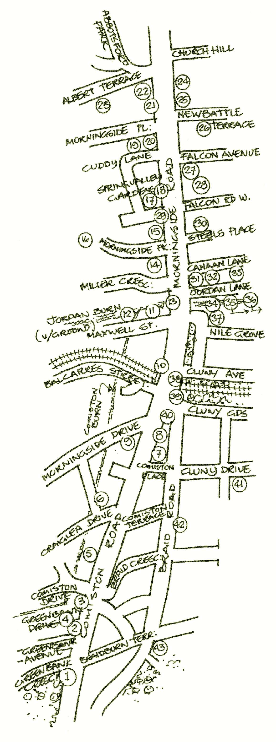

© 2013 Fiona Brownlee & Morningside Heritage Association

