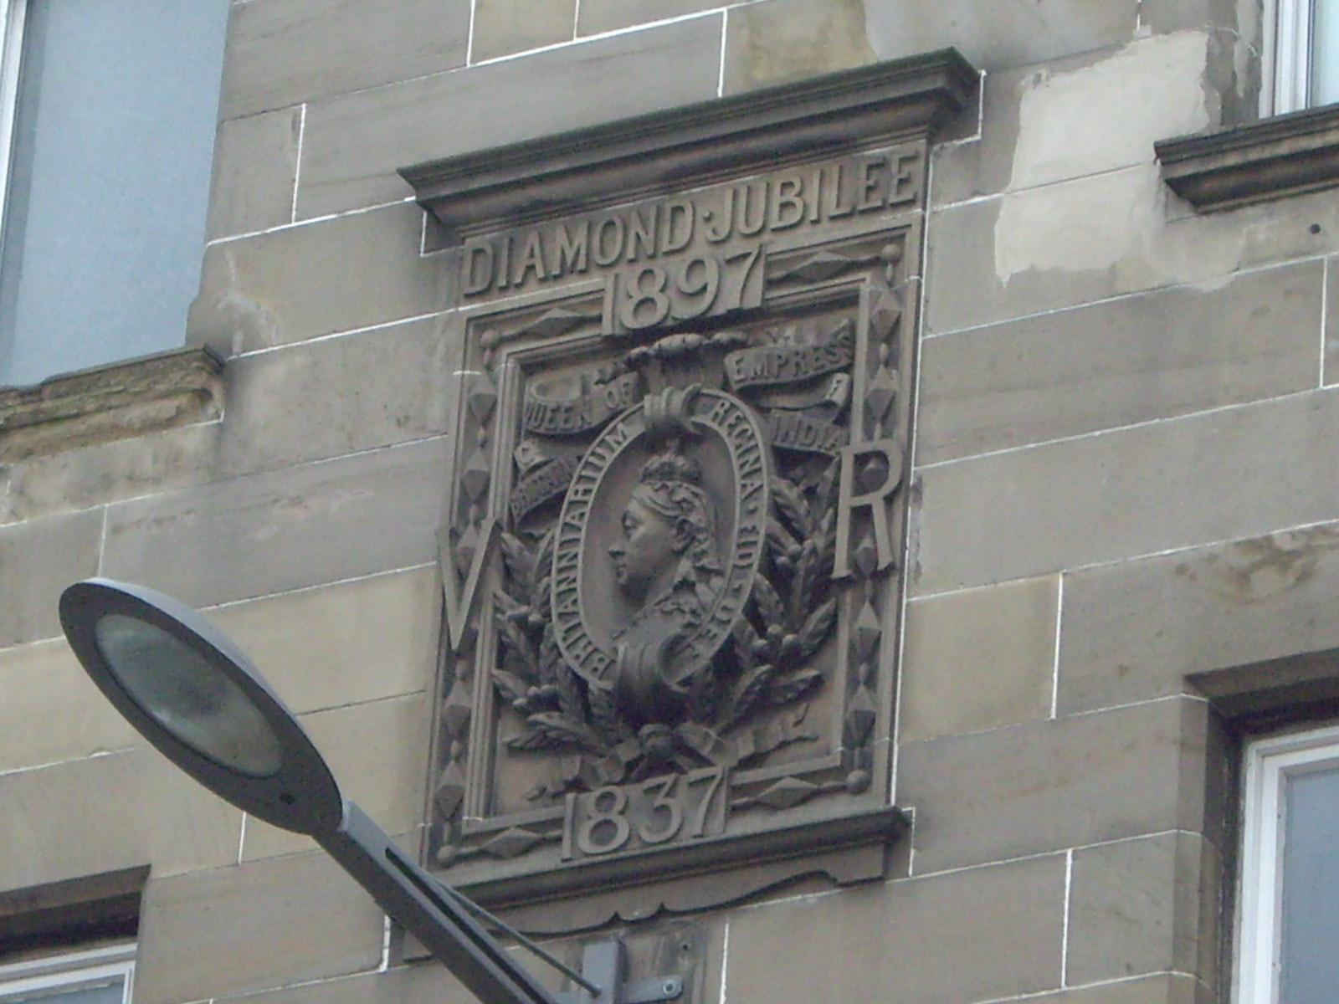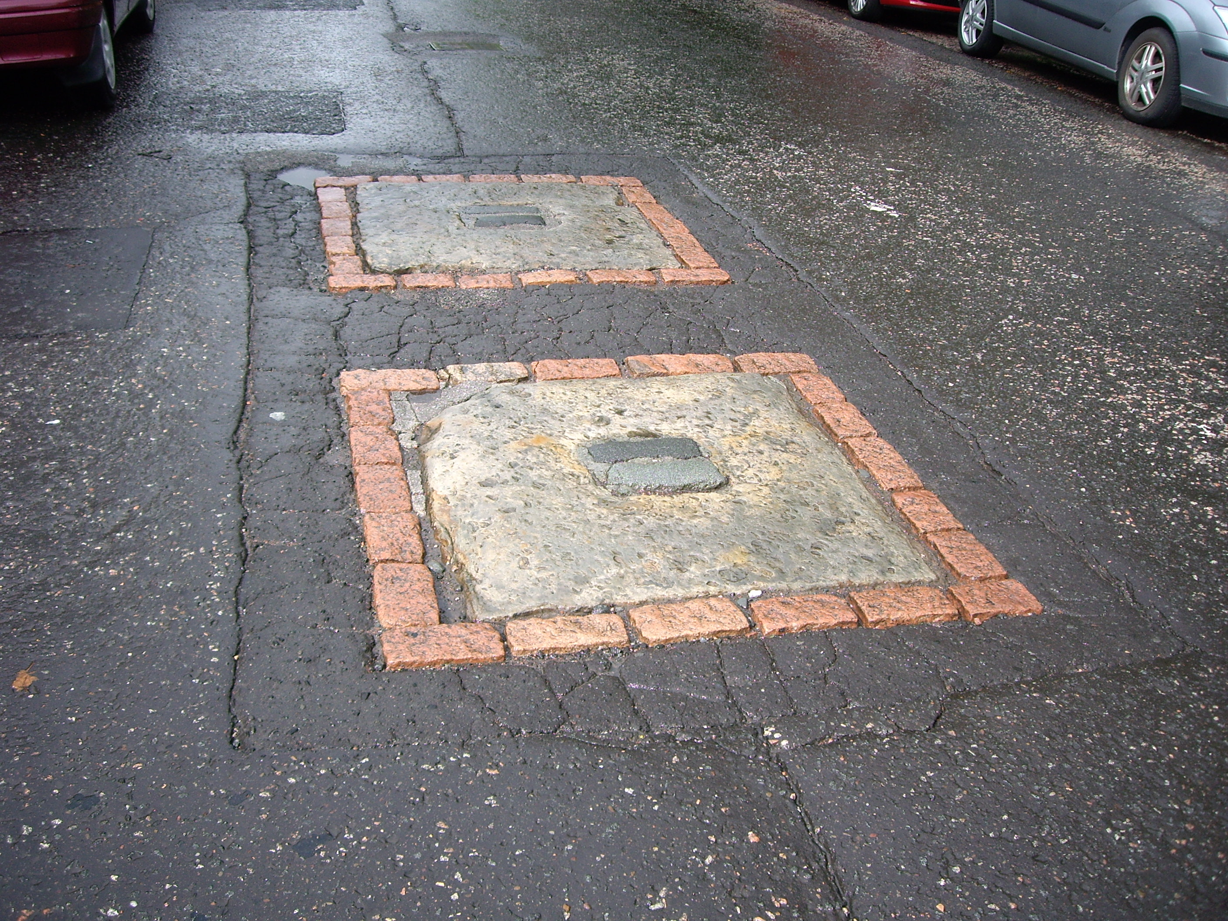

7 8
See if you can find all these places in these photographs!


© 2013 Fiona Brownlee & Morningside Heritage Association

